**Cricket Score Board Display**

Project Report

***Submitted in partial fulfillment of the requirement for the award of the degree of***

**BACHELOR OF TECHNOLOGY**

**Computer Science and Engineering**

SUBMITTED BY

Vishal Kumar Kushwaha

(2100460100119)



**Dr. APJ Abdul Kalam Technical University,**

**Uttar Pradesh,**

**Lucknow ,India**



Maharana Pratap Engineering College, Kanpur

Certificate

This is to certify that Vishal Kumar Kushwaha of B.Tech CS 2nd year of Maharana Pratap Engineering College has successfully completed the project on Cricket Score Board display under the guidance of

Mr. Subhash Chandra Maurya in the year 2022-23.

Date-01/11/2022 Signature

…………………………..

Acknowledgement

I would like to express my special thank of gratitude to my teacher “Mr. Subhash Chandra Maurya” for their guidance and support in completing my project.

I would also like to extend my gratitude to the HOD “Mr. Saurabh Singh” for providing me with all the facility that was required.

Date- Vishal Kumar Kushwaha

01/12/2022 B.Tech CS-2nd year, Sec-A2

**INDEX**

1. Introduction of the Problem ………………………………………………………...5-8
2. Objective (Problem Statement………………………………………………………...9
3. System requirements………………………………………………………………… 10
   1. Hardware requirements
   2. Software requirements
4. Algorithm/Flowchart ……………………………………………………………. 11-12
5. Literature review ……………………………………………………………………..13
6. Technology used
   1. C Language …………………………………………………………………. 14
   2. History of C language …………………………………………………….14-15
   3. Structure of C Program……………………………………………………16-18
   4. Features of C ………………………………………………………………19-20
   5. Application of C Language………………………………………………..21-22
   6. Types of escape sequence…………………………………………………….23
7. Output Screen Shots……………………………………………………………….24-27
8. Conclusion……………………………………………………………………………28
9. Test Analysis …………………………………………………………………………29
10. Future Scope…………………………………………………………………………..30
11. References………………………………………...…………………………………..31
12. Appendix
    1. Code of the Solution……………………………………………………..32-40

**Introduction of the Problem-**

This cricket score board display project in C is only a project made for college requirement purpose only. This is created specifically for a semester project.

It aim is to show all the basic details of a cricket match. This is a basic program and easy to understand.

In this project only basic details are included by us and the details which are stored in it by us it will display all of them in a sequence when we will choose the choice in it. Only Chosen choice details will show other details will appear only when we will enter choice for that.

Like-

When we run the project it will firstly ask to enter the batsman details and when we enter the different batsman details after that it will ask details about bowlers after that it will store all the details. It will now show different choices like-

1)Batsman details:

2)Bowlers details:

3)Match summary:

4)Record:

5)Exit

When we will enter choice 1 then it will show the details about the batsman, when we will enter 2 it will show all bowlers details ,3rd choice will show the summary of the match, 4th choice enter by us will show the records and last when we will enter 5 then the program will get exit. It will display only that details which we will enter at execution of program , no any details in it will be stored for future use, if we will want to see again and again the details then first we have to enter all the details first.

So I have regarded it as a simple Score board management system program of C language.

Going to the project step by step-

In the first module the program will get execute and will ask to enter the number of batsman and when we will enter the number then it will ask about the name batsman and after entering the name it will ask one by one-

* Run scored by the batsman
* Ones scored by batsman
* Twos scored by batsman
* Three scored by batsman
* Four scored by batsman
* Sixes scored by batsman
* Total balls played by batsman

It will ask till the number of batsman what we entered. And it will calculate the strike rate through the input what we entered.

Now in the second module we come to the point that it will ask about the Bowler details and in this it will ask to enter number of bowlers and when we will enter the number of batsman then it will ask about the bowler details like-

* Wickets taken by the bowler
* Run given by the bowler
* Over thrown by bowler

After entering these input all the records will get stored in it and it will calculate the economy for the bowler.

In coming to third module we come across the points that all data are stored and the choice will come as output and we have to enter the choices to see the -

1)Batsman details:

2)Bowlers details:

3)Match summary:

4)Record:

5)Exit

And from the above points what we want to see then we will enter the choice.

If we will enter the first choice then it will ask to enter the number of batsman to see his details and when we enter that then on the basis of that input it will show the details of the batsman.

In this output it will show all the details like-run scored , sixed scored ,four scored as well as strike rate of that batsman.

If we will enter the choice no 2 then it will ask to enter the number of bowler whose details I want to see ,then whose details we want to see we will enter that number to see the details of that bowler.

In this output it will show all the details like-over thrown , wicket taken, runs given, as well as economy of that bowler.

If we want to see the summary of the match then we will choose the choice number 3 from that the output will come in which every details what we entered at the time of first module will display in the sequential manner which we can see in the output screen shot of number 10.

After that when we want to see the record about the match then we will enter the choice number 4 in which we will be able to see the following points-

* Highest runs scored by batsman.
* Maximum sixes scored by batsman.
* Maximum four scored by batsman.
* Maximum wicket taken by the bowler.

At last when we want to exit from the program we will choose the option number 5 and where the exit() command will come into existence.

These are the following process which are executed during the program and all the output which are obtained from that program are listed below.

There are several keyword and formulas are used in the code of project to calculate the economy and strike rate for the bowler and batsman.

**Objective-**

The Cricket score board display is a simple program written in C language.

It employs file management to store the data like as runs, wickets, overs and extras, among other things.

The project may show runs, wickets, batsman and bowler details, overs, bowler economy, batsman strike rate, and so on.

The code is devoid of errors, and simple to understand.

**System Requirements-**

* Software Requirements-

i) Operating System-

Window 7 and later OS.

ii) Dev-C++

* Hardware Requirements-
  + 1. Processor-intel core i3 and later
    2. Disk space- minimum 1Gb

**Algorithm-**

* Start
* Create structure for batsman
* Create structure for bowler
* Choice for batsman (no of batsman)
* Fill details of batsman
* Choice for bowler 21(no of bowler)
* Fill the details of bowler
* Choice to see details
* Exit
* Stop

**Flowchart-**

Start

Stop

5

4

Exit

Record

Bowler details

Match Summary

Batsman Details

3

2

1

Choice

Fill details

Fill details

Bowler

Batsman

Create Structure

**Literature Review-**

Abstract-

Today’s in cricket, the performance of the teams is being analyzed by using very simple statistical tools and graphics. Most of the times, the average scores , strike rates,graphical measures are being utilized to measure the performance and to make comparison between different teams.

The main focus of the research paper is to provide the details and the idea to evaluate and make the project cut to cut clear and understable.

Introduction-

Cricket has become one of the world class famous and popular game. It is the game of bat and ball which includes eleven players. Most of analysis is being conducted to measure the performance of the team and time to time record of every event of the cricket.

The experts of this game give their opinions in the lights of this information.

The performance of the players and teams in cricket has been analyzed with the help of very simple statistical tools. During the few years back , a huge study and work has been conducted to measure the performance of the teams and the prediction of their performance.

The present research paper gives the basic idea to use the score card digitally through these kind of projects.[6]

**Technology Used-**

***C Language****-* C is a structured, procedural programming language that has been widely used both for operating systems and applications and that has had a wide following in the academic community.

It was initially developed by Dennis Ritchie in the year 1972. It was mainly developed as a system programming language to write an operating system. The main features of the C language include low-level memory access, a simple set of keywords, and a clean style, these features make C language suitable for system programming like an operating system or compiler development.

Many later languages have borrowed syntax/features directly or indirectly from the C language. Like syntax of Java, PHP, JavaScript, and many other languages are mainly based on the C language.

**History of C language:-**

The base or father of programming languages is ‘ALGOL.’ It was first introduced in 1960. ‘ALGOL’ was used on a large basis in European countries. ‘ALGOL’ introduced the concept of structured programming to the developer community. In 1967, a new computer programming language was announced called as ‘BCPL’ which stands for Basic Combined Programming Language. BCPL was designed and developed by Martin Richards, especially for writing system software. This was the era of programming languages. Just after three years, in 1970 a new programming language called ‘B’ was introduced by Ken Thompson that contained multiple features of ‘BCPL.’ This programming language was created using UNIX operating system at AT&T and Bell Laboratories. Both the ‘BCPL’ and ‘B’ were system programming languages.

In 1972, a great computer scientist Dennis Ritchie created a new programming language called ‘C’ at the Bell Laboratories. It was created from ‘ALGOL’, ‘BCPL’ and ‘B’ programming languages. ‘C’ programming language contains all the features of these languages and many more additional concepts that make it unique from other languages.

‘C’ is a powerful programming language which is strongly associated with the UNIX operating system. Even most of the UNIX operating system is coded in ‘C’. Initially ‘C’ programming was limited to the UNIX operating system, but as it started spreading around the world, it became commercial, and many compilers were released for cross-platform systems. Today ‘C’ runs under a variety of operating systems and hardware platforms. As it started evolving many different versions of the language were released. At times it became difficult for the developers to keep up with the latest version as the systems were running under the older versions. To assure that ‘C’ language will remain standard, American National Standards Institute (ANSI) defined a commercial standard for ‘C’ language in 1989. Later, it was approved by the International Standards Organization (ISO) in 1990. ‘C’ programming language is also called as ‘ANSI C’.

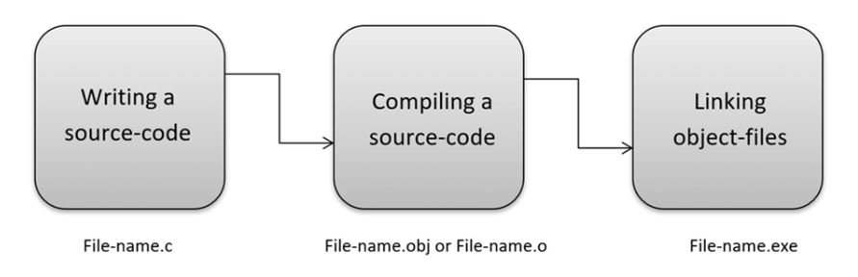

Nowadays, various compilers are available online, and you can use any of those compilers. The functionality will never differ and most of the compilers will provide the features required to execute both ‘C’ and ‘C++’ programs.

Following is the list of popular compilers available online:

* Clang compiler
* MinGW compiler (Minimalist GNU for Windows)
* Portable ‘C’ compiler
* Turbo C

**Structure of a C program : -**

1. **Header Files Inclusion**
2. **Main Method Declaration**
3. **Variable Declaration**
4. **Body**
5. **Return Statement**

**Header Files Inclusion**:

The first and foremost component is the inclusion of the Header files in a C program.   
A header file is a file with extension .h which contains C function declarations and

macro definitions to be shared between several source files.

Some of C Header files:

1. stddef.h – Defines several useful types and macros.

stddef.h is a header file in the standard library of the C programming language that defines the macros NULL and offsetof as well as the types ptrdiff_t, wchar_t, and size_t.

1. stdint.h – Defines exact width integer types.

stdint.h is a header file in the C standard library introduced in the C99 standard library section 7.18 to allow programmers to write more portable code by providing a set of typedefs that specify exact-width integer types, together with the defined minimum and maximum allowable values for each type, using macros .

1. stdio.h – Defines core input and output functions.

The header file stdio.h stands for Standard Input Output. It has the information related to input/output functions.

1. stdlib.h – Defines numeric conversion functions, pseudo-random network generator, memory allocation.
2. string.h – Defines string handling functions.The **string.h** header defines one variable type, one macro, and various functions for manipulating arrays of characters.
3. math.h – Defines common mathematical functions.

The **math.h** header defines various mathematical functions and one macro. All the functions available in this library take **double** as an argument and return **double** as the result.

**Main Method Declaration:** The next part of a C program is to declare the main() function. The syntax to declare the main function is:**Syntax to Declare the** **main method:** **int main ()**

**Variable Declaration:** The next part of any C program is the variable declaration.

It refers to the variables that are to be used in the function. Please note that in the

C program, no variable can be used without being declared. Also in a C program,

The variables are to be declared before any operation in the function.

**Body:** The body of a function in the C program, refers to the operations that are performed in the functions. It can be anything like manipulations, searching, sorting, printing, etc.

Example-

int main()

{

int a;

**printf("%d", a);**

**.**

**.**

**.**

}

**Return Statement:** The last part of any C program is the return statement. The return statement refers to the returning of the values from a function. This return statement and return value depend upon the return type of the function. For example, if the return type is void, then there will be no return statement. In any other case, there will be a return statement and the return value will be of the type of the specified return type.

Example-

int main()

{

int a;

printf("%d", a);

**return 0;**

}

Some Features of C language are:

1. Procedural Language
2. Fast and Efficient
3. Modularity
4. Statically Type
5. General-Purpose Language
6. Rich set of built-in Operators
7. Libraries with rich Functions
8. Middle-Level Language
9. Portability
10. Easy to Extend

**Details about features of C -**

* **Procedural Language:** In a procedural language like C step by step predefined instructions are carried out. C program may contain more than one function to perform a particular task.
* **Fast and Efficient:** Newer languages like java, python offer more features than c programming language but due to additional processing in these languages, their performance rate gets down effectively. It’s fast because statically typed languages are faster than the Dynamically typed language.
* **Modularity:** The concept of storing C programming language code in the form of libraries for further future uses is known as modularity.
* **General Purpose Language:** From system programming to photo editing software, the C programming language is used in various applications. Some of the common applications where it’s used are as follows:
  + [Operating systems](https://www.geeksforgeeks.org/operating-systems/): Windows, [Linux](https://www.geeksforgeeks.org/linux-vs-unix/), iOS, [Android](https://www.geeksforgeeks.org/android-app-development-fundamentals-for-beginners/)
  + [Databases](https://www.geeksforgeeks.org/dbms/): PostgreSQL, Oracle, [MySQL](https://www.geeksforgeeks.org/sql-tutorial/), MS SQL Server etc.
* **Rich set of built-in Operators:** It is a diversified language with a rich set of built-in [operators](https://www.geeksforgeeks.org/operators-c-c/) which are used in writing complex or simplified C programs.
* **Libraries with rich Functions:** Robust libraries and [functions in C](https://www.geeksforgeeks.org/functions-in-c/) help even a beginner coder to code with ease.
* **Middle-Level Language:** As it is a middle-level language so it has the combined form of both capabilities of assembly language and features of the [high-level language](https://www.geeksforgeeks.org/difference-between-high-level-and-low-level-languages/).
* **Portability:** C language is lavishly portable as programs that are written in C language can run and compile on any system with either none or small changes.
* **Easy to Extend:** Programs written in C language can be extended means when a program is already written in it then some more features and operations can be added to it.

**Application of C Language-**

It is a true fact that C is one of the oldest and most fundamental languages which is widely used across the world. C is fast, portable, and has a rich library. C is a middle-level language but it has benefits of low-level languages as well as high-level languages. And it is sad to hear that the use of C programming is decreasing day by day. C has left its mark in almost every domain. C is mainly used to develop applications and for system development work.

Real-World Applications of C-

* **Operating System-**A high-level programming language built in the C programming language was used to construct the first operating system, which was UNIX. Later on, the C programming language was used to write Microsoft Windows and several Android apps.
* **GUI (Graphical User Interface)-**Since the beginning of time, Adobe Photoshop has been one of the most widely used picture editors. It was created entirely with the aid of the C programming language. Furthermore, C was used to develop Adobe Illustrator and Adobe Premiere.

* **Embedded Systems: -**In daily life, we use different embedded systems like coffee machines, microwaves, climate control systems etc. These all are mostly programmed in C.
* **Database:-**The C programming language helps in developing the popular database management system, MySQL
* **Gaming:-**C programming is relatively faster than Java or Python. It has been used in various gaming applications and graphics. C programming language also helps in creating many popular childhood games like Tic-Tac-Toe, The Snake game etc.
* **Development of New languages:-**Due to the fast execution and simplicity, many languages like Java, C++, Python, PHP, PERL, JavaScript, etc were influenced by the development of C. In Python, C is used for building standard libraries. The syntax and control structures of PERL, PHP and C++ are based upon the C programming language.
* **Google-** In the Google open source community, the projects are being handled by C/C++. And C/C++ also helped in developing google file system and chromium browser.
* **Assemblers:-** Mainly used to translate Assembly language to Machine language. C also helped in developing GNU assembler.
* **Text Editors:-** C also helped in creating various text editors like Vim, Gedit etc.
* **Drivers:-** Another application of C is to write driver softwares like Keyboard driver, Network driver, mouse driver etc.
* **Interpreters:-** With the help of C programming language, you can create language interpreters. C helped in developing different programming language interpreters like Python and MATLAB interpreters etc.

**Type of Escape sequence in C:-**

1. **\n** (New line) – We use it to shift the cursor control to the new line
2. **\t** (Horizontal tab) – We use it to shift the cursor to a couple of spaces to the right in the same line.
3. **\a** (Audible bell) – A beep is generated indicating the execution of the program to alert the user.
4. **\r** (Carriage Return) – We use it to position the cursor to the beginning of the current line.
5. **\\** (Backslash) – We use it to display the backslash character.
6. **\’** (Apostrophe or single quotation mark) – We use it to display the single-quotation mark.
7. **\”** (Double quotation mark)- We use it to display the double-quotation mark.
8. **\0** (Null character) – We use it to represent the termination of the string.
9. **\?** (Question mark) – We use it to display the question mark. (?)
10. **\nnn** (Octal number)- We use it to represent an octal number.
11. **\xhh** (Hexadecimal number) – We use it to represent a hexadecimal number.
12. **\v** (Vertical tab)
13. **\b** (Backspace)
14. **\e** (Escape character)
15. **\f** (Form Feed page break)

**Output Screenshots-**

Output No.3

Output No.2

Output No.1

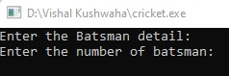

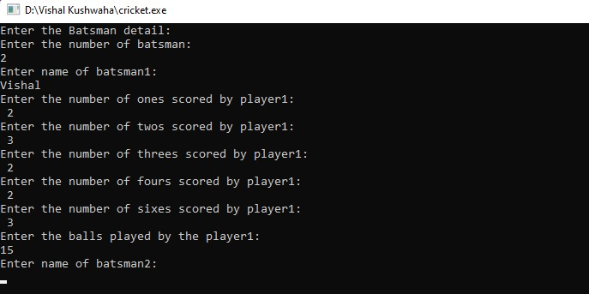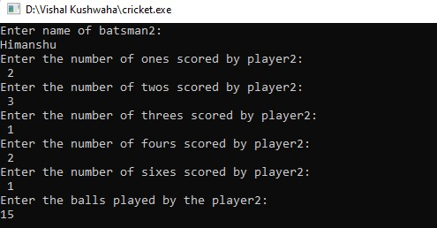

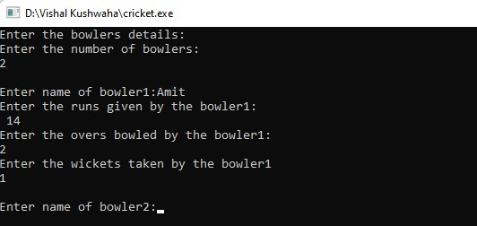

Output No.4

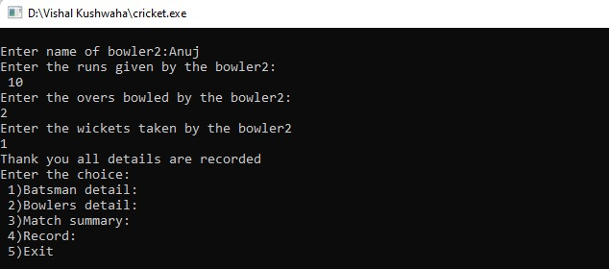

Output No.5

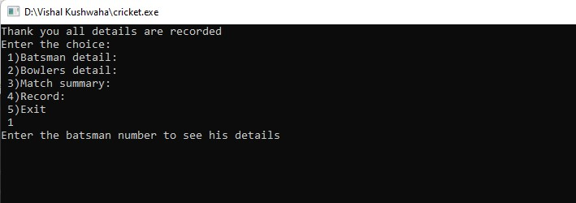

Output No.6

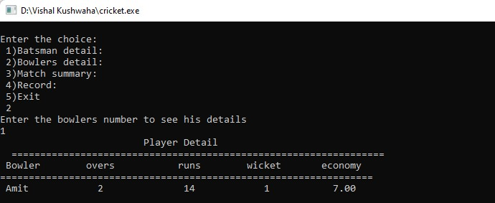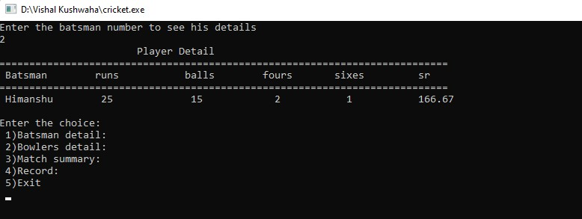

Output No.7

Output No.8

Output No.6

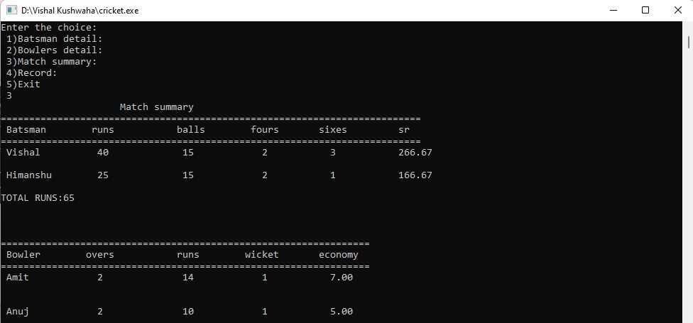

Output No.8

Output No.7

Output No.9

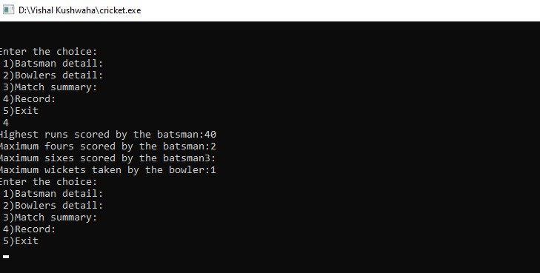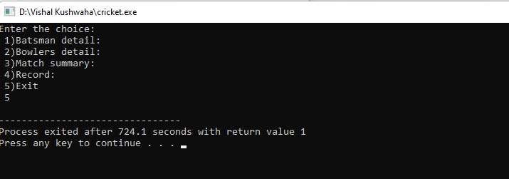

Output No. 10

Output No.11

**Conclusion-**

This cricket score board display project in C is only a project made for college requirement purpose only. This is created specifically for a semester project.

In this project only basic details are included by us and the details which are stored in it by us it will display all of them in a sequence when we will choose the choice in it. Only chosen choice details will show other details will appear only when we will enter choice for that.

The data or the information which we will upload in it will not be store for the future use. It will only execute or display at the time of executing the program.

As at the early period all the score are display through the boards. But with the help of this project we can display our scorecard digitally. It is the starting of my project I would like to add some more new features in it for the future use.

**Test Analysis-**

**Case 1-**

Printf function is used to print the content of the program like entering of batsman, bowler details with different points.

**Case 2-**

**Switch statement** is used to put down different types of choices .With the help of this function different choices can be accessed from the program till we don’t use option for exit.

**Case 3-**

Different formula are used to calculate the strike rates, bowlers details.

**Case 4-**

Spacing command are used in the function to make space between two words so that it could be understable that which lines or word is showing for which topic.

The command are-

“%-15s %-14d %-13d %-11d” this is used for making space.

**Future Scope-**

* This project is a simple data management of Cricket. No data is stored for again use.

I will try to make it as advance so that it will be useful for future use.

* Only one inning of data is stored in it so the advance feature can be use in it to store both inning data and can be displayed at same time.
* Through this an app can be developed which will help in understanding it clearly.
* Not only the scorecard aur batsman , bowler details will stored but also through adding more features different types of records can be stored for future purpose and can be accessed when we want.

**References-**

1. https://www.geeksforgeeks.org/
2. http://www.allprogramminghindi.in/
3. academia.edu
4. scribed.com
5. https://www.javatpoint.com/
6. Middle east journal of scientific research

**Appendix**

**Project Code-**

#include<stdio.h>

#include<stdlib.h>

**//creating a structure for batsman-**

struct batsman

{

char name[25];

int runs,score,balls,toruns,tobal,ones,twos,threes,fours,sixes;

int max_six,max_run,max_four;

float str;

}pl1[100],pl3;

**//creating structure for bowlers-**

struct bowler

{

char name[25];

int runsgv,wkttkn,overs;

int max_w;

float econ;

}pl2[100],pl4;

//**In the main function of the program, the user will be asked to enter the choice-**

int main()

{

int plno,choice;

int i,n,m;

printf("Enter the Batsman detail:\n");

printf("Enter the number of batsman:\n");

scanf("%d",&m);

**//Score details of the batsman will be handled by below code-**

for(i=0;i<m;i++)

{

printf("Enter name of batsman%d:\n",i+1);

scanf("%s",pl1[i].name);

printf("Enter the number of ones scored by player%d:\n ",i+1);

scanf("%d",&pl1[i].ones);

printf("Enter the number of twos scored by player%d:\n ",i+1);

scanf("%d",&pl1[i].twos);

printf("Enter the number of threes scored by player%d:\n ",i+1);

scanf("%d",&pl1[i].threes);

printf("Enter the number of fours scored by player%d:\n ",i+1);

scanf("%d",&pl1[i].fours);

printf("Enter the number of sixes scored by player%d:\n ",i+1);

scanf("%d",&pl1[i].sixes);

printf("Enter the balls played by the player%d:\n",i+1);

scanf("%d",&pl1[i].balls);

}

printf("\nEnter the bowlers details:\n");

printf("Enter the number of bowlers:\n");

scanf("%d",&n);

**//bowler details will be handled by below code-**

for(i=0;i<n;i++)

{

printf("\nEnter name of bowler%d:",i+1);

scanf("%s",pl2[i].name);

printf("Enter the runs given by the bowler%d:\n ",i+1);

scanf("%d",&pl2[i].runsgv);

printf("Enter the overs bowled by the bowler%d:\n",i+1);

scanf("%d",&pl2[i].overs);

printf("Enter the wickets taken by the bowler%d\n",i+1);

scanf("%d",&pl2[i].wkttkn);

}

printf("Thank you all details are recorded\n");

do

{

printf("Enter the choice:\n 1)Batsman detail:\n 2)Bowlers detail:\n 3)Match summary:\n 4)Record:\n 5)Exit\n ");

scanf("%d",&choice);

//**If the user has chosen the option 1 to add the details of the batsman than the below code will come into the action-**

switch(choice)

{

case 1:

printf("Enter the batsman number to see his details\n");

scanf("%d",&plno);

plno--;

printf(" Player Detail\n");

printf("===========================================================================\n");

printf(" Batsman runs balls fours sixes sr \n");

printf("===========================================================================\n"); pl1[plno].runs=(1*pl1[plno].ones)+(2*pl1[plno].twos)+(3*pl1[plno].threes)+(4*pl1[plno].fours)+(6*pl1[plno].sixes);

pl1[plno].str=(pl1[plno].runs*100.00)/pl1[plno].balls;

printf(" %-15s %-14d %-13d %-11d %-11d %-9.2f\n\n",pl1[plno].name,pl1[plno].runs,pl1[plno].balls,pl1[plno].fours,pl1[plno].sixes,pl1[plno].str);

break;

//**If the user has chosen the option 2 to add the details of the bowler then the below code will come into the action-**

case 2:

printf("Enter the bowlers number to see his details\n");

scanf("%d",&plno);

plno--;

printf("PlayerDetail\n"); printf("=================================================================\n");

printf(" Bowler overs runs wicket economy\n");

printf("=================================================================\n");

for(i=0;i<n;i++)

{ pl2[plno].econ=pl2[plno].runsgv/pl2[plno].overs;

printf(" %-15s %-14d %-13d %-11d %-11.2f\n\n",pl2[plno].name,pl2[plno].overs,pl2[plno].runsgv,pl2[plno].wkttkn,pl2[plno].econ);

}

break;

//**If the user wants to see the match summary then he will choose option 3 then the below code will come in the execution of the program-**

case 3:

printf(" Match summary\n");

printf("==========================================================================\n");

printf(" Batsman runs balls fours sixes sr \n");

printf("==========================================================================\n");

for(i=0;i<m;i++)

{ pl1[i].runs=(1*pl1[i].ones)+(2*pl1[i].twos)+(3*pl1[i].threes)+(4*pl1[i].fours)+(6*pl1[i].sixes);

pl3.toruns+=pl1[i].runs;

pl1[i].str=(pl1[i].runs*100.00)/pl1[i].balls;

printf("%-15s%-14d%-13d%-11d%-11d%-9.2f\n\n",pl1[i].name,pl1[i].runs,pl1[i].balls, pl1[i].fours,pl1[i].sixes,pl1[i].str);

}

printf("TOTAL RUNS:%d\n\n",pl3.toruns);

printf("\n\n"); printf("=================================================================\n");

printf(" Bowler overs runs wicket economy\n");

printf("=================================================================\n");

for(i=0;i<n;i++)

{ pl2[i].econ=pl2[i].runsgv/pl2[i].overs;

printf(" %-15s %-14d %-13d %-11d %-11.2f\n\n\n",pl2[i].name,pl2[i].overs,pl2[i].runsgv,pl2[i].wkttkn,pl2[i].econ);

}

break;

//**The below code will work in case of 4 as user chose it to display the Highest runs scored by the batsman,** **Maximum fours scored by the batsman, Maximum sixes scored by the batsman,** **Maximum wickets taken by the bowler.**

case 4: pl3.max_run=0,pl4.max_w=0,pl3.max_four=0,pl3.max_six=0;

for(i=0;i<m;i++)

{ pl1[i].runs=(1*pl1[i].ones)+(2*pl1[i].twos)+(3*pl1[i].threes)+(4*pl1[i].fours)+(6*pl1[i].sixes);

if(pl3.max_run<pl1[i].runs)

{

pl3.max_run=pl1[i].runs;

}

if(pl3.max_six<pl1[i].sixes)

{

pl3.max_six=pl1[i].sixes;

}

if(pl3.max_four<pl1[i].fours)

{

pl3.max_four=pl1[i].fours;

}

if(pl4.max_w<pl2[i].wkttkn)

{

pl4.max_w=pl2[i].wkttkn;

}

}

printf("Highest runs scored by the batsman:%d\n",pl3.max_run);

printf("Maximum fours scored by the batsman:%d\n",pl3.max_four);

printf("Maximum sixes scored by the batsman%d:\n",pl3.max_six);

printf("Maximum wickets taken by the bowler:%d\n",pl4.max_w);

break;

**//if we want to exit from the program then this code will come in execution**

case 5:

exit(1);

default:

printf("Enter the correct choice\n");

break;

}

}while(choice!=5);

return 0;

}